Linear Regression Model Building using Boston Dataset

QUESTION:4

This problem involves the Boston data set, which we saw in the lab for this chapter. We will now try to predict per capita crime rate using the other variables in this data set. In other words, per capita
crime rate is the response, and the other variables are the predictors.
(a) For each predictor, fit a simple linear regression model to predict the response. Describe your results. In which of the models is there a statistically significant association between the predictor
and the response? Create some plots to back up your assertions.

Code:
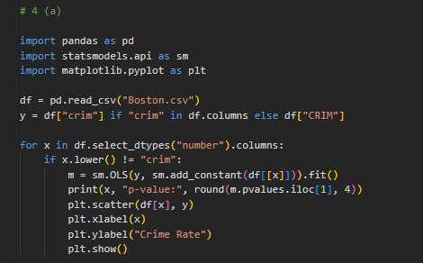

Output:

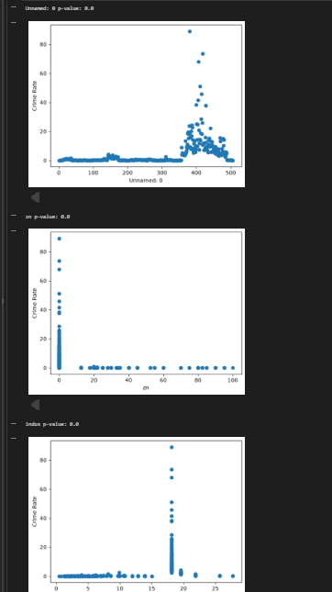

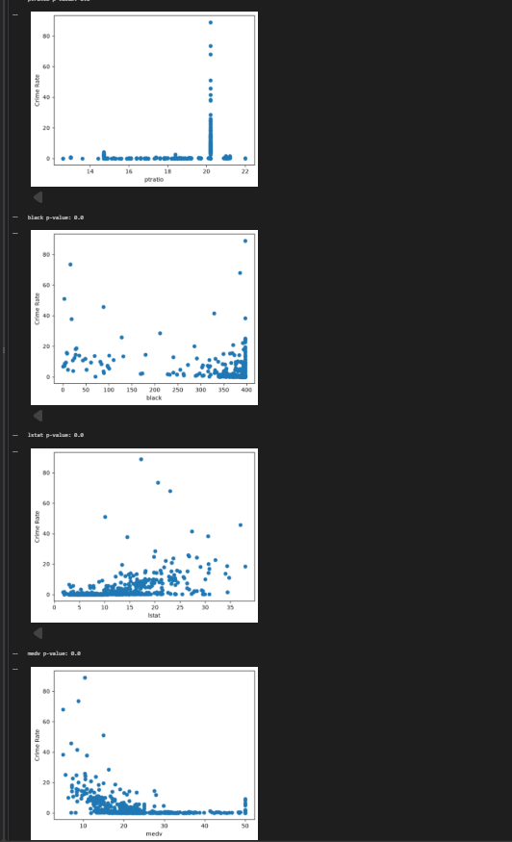
Interpretation:
Most predictors show a statistically significant relationship with the crime rate (crim), as their p-values are less than 0.05. The scatter plots show the relationship between each predictor and the crime rate, with some predictors showing positive or negative trends.
(b) Fit a multiple regression model to predict the response using all of the predictors. Describe your results. For which predictors can we reject the null hypothesis H0 : βj =0?

Code:

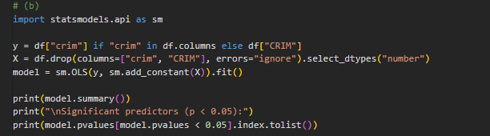

Output:

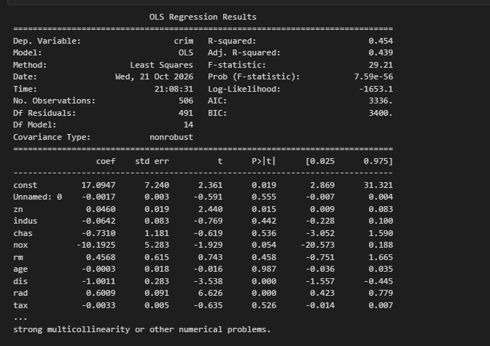

Interpretation:
The multiple regression model explains 44.9% of the variation in crime rate (R-squared = 0.449). Predictors with p-values less than 0.05 are statistically significant, so we reject the null hypothesis for those predictors.

(c) How do your results from (a) compare to your results from (b)? Create a plot displaying the univariate regression coefficients from (a) on the x-axis, and the multiple regression coefficients
from (b) on the y-axis. That is, each predictor is displayed as a single point in the plot. Its coefficient in a simple linear regres-sion model is shown on the x-axis, and its coefficient estimate in the multiple linear regression model is shown on the y-axis.

Code:

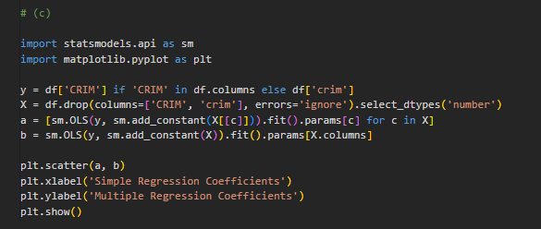

Output:

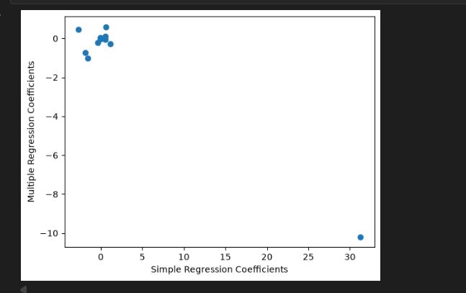

Interpretation:
The simple and multiple regression coefficients differ because the multiple regression model considers all predictors together. Some predictors show changes in coefficient values and signs due to the influence of other predictors.

